**Template for Documenting API Testing**

Student Name: Jonnie Carino  
Student Number: B00835055

**Dataset Tables: categories collection**

Provide evidence of testing 5 endpoints.

**Endpoint 1**

**Endpoint Address**: /get_math_tags

Pytest:

**Several lines describing the test:**

This test fixture is to verify the /get_math_tags endpoint which retrieves the documents from the categories collection that have a tag with the name of “math”. It checks the response from the /get_math_tags endpoint to see if it contains the expected data.

**Endpoint 2**

**Endpoint Address**: /get_mmt_severity_high

Pytest :

**Several lines describing the test:**

This test fixture is to verify the /get_mmet_severity_high endpoint which retrieves documents from the categories collection that have a categeory field of "Method, Mathematics and Terminology", a severity field value of "High" and a Priority field value of "Critical". It then checks that the response from the /get_mmet_severity_high endpoint contains the expected data.

**Endpoint 3**

**Endpoint Address**: /get_appendix_missingContent_tag

Pytest:

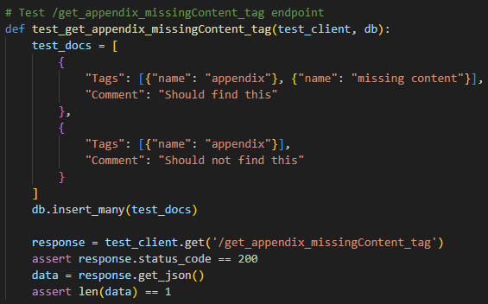

**Several lines describing the test:**

This test fixture is to verify the / get_appendix_missingContent_tag endpoint which retrieves documents from the categories collection that have both “appendix” tag and “missing content” tag. It then checks that the response from the /get_appendix_missingContent_tag endpoint contains the expected data.

**Endpoint 4**

**Endpoint Address**:/get_doc_15th_onwards

Pytest:

**Several lines describing the test:**

This test fixture is to verify the /get_doc_15th_onwards endpoint which retrieves documents from the categories collection that have a date field of January 20, 2024, or later. It then checks that the response from the /get_mmet_severity_high endpoint contains the expected data.

**Endpoint 5**

**Endpoint Address**: /get_important_technical_tag

Pytest:

**Provide few lines describing the test.**

This test fixture is to verify the /get_important_technical_tag endpoint which retrieves documents from the categories collection that have tag with a category field of “technical” and “importance” value of 4 or greater. It then checks that the response from the /get_important_technical_tag endpoint contains the expected data.

**Pytest output – Success message screenshot**

Assertion error on status code

